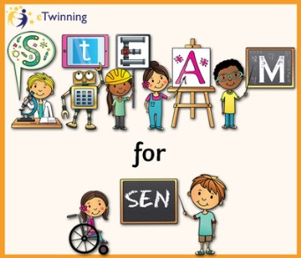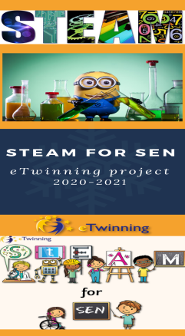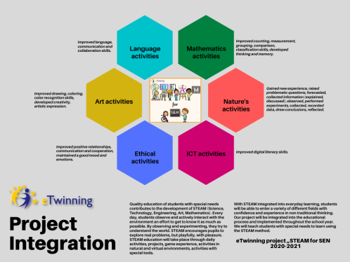
https://steamforsen.weebly.com/

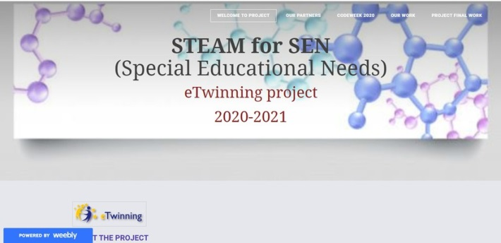
https://www.storyjumper.com/book/read/109165656/60b0c9c311532

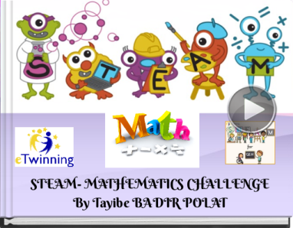
https://www.storyjumper.com/book/read/104918616
https://read.bookcreator.com/GqTC6x01D3TcSfFzDQ3zSFA9aS42/0fDKRxpfRSa_3U_yHs4S_g
https://www.storyjumper.com/book/read/108706646/60ab7636308f4

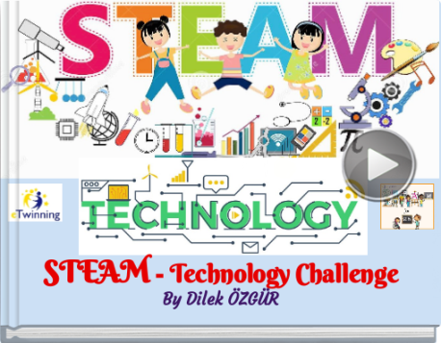
https://www.ourboox.com/books/january-engineering-activities/

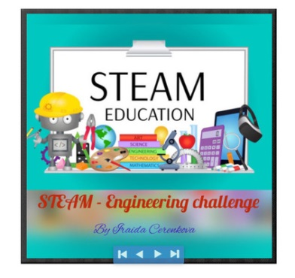

https://www.storyjumper.com/book/read/104918616

https://www.canva.com/design/DAEerXkZ3uw/4GV55VaJ96Z6zxab6lsHnA/view?utm_content=DAEerXkZ3uw&utm_campaign=designshare&utm_medium=link&utm_source=publishsharelink
https://youtu.be/4rzdq9vyMGk
https://youtu.be/EVdQYQd4QkU
https://animoto.com/play/W8jyt096WW7nOBH4ZaQoeQ
https://animoto.com/play/27LkDeYjA24xjFudJp1p9A

